**GSOE9820**

**Engineering Project Management**

Web Based Project

Project 2: Develop a WBS For a Local Stage Play

**Final Project Report**



**Group members**

Feng Yu  
Likun Cui  
Danish Imtiaz  
Jinpeng Gu  
Wei He  
Yubo Zhang

**Faculty of Engineering**

**University of New South Wales**

TABLE OF CONTENTS

Executive summary………………………………….…………….……………………….1

Introduction………………………………………………………………………………….2

Evaluations and analysis............................................................................................3

Conclusion………………………………………………………………………………….11

Lessons Learnt…………………………………………………………………………….11

EXECUTIVE SUMMARY

This project is essentially a meta-project that works on a work breakup structure (WBS) for a local stage play. The topic offered to us was rather general, and it was up to us to determine what stage play it will be like. Since there were 7 deliverables for this meta-project and we had only 2 weeks, the time table of discussion was intensive, allowing 2 days in average to work out each deliverable item. For each topic, every one of our team, including the PM’s, first present his/her individual schedule, and then discuss in order to reach an agreement. There were some discrepancies during discussion, but they mostly differ at the detail level, and through discussion, we adjusted out opinions while listening to other’s reasoning. Final opinions were then forged through logical reasoning as possible, but also through following the opinion of the majority.

INTRODUCTION

In this project, we are required to develop a work breakdown structure (WBS) for a stage play which involves the scope, the main deliverables, a WBS in hierarchy, an organization breakdown structure (OBS). After that, we will intersect the WBS with the OBS to work out an example of the work packages.

Our team consists of 6 members, including 2 project managers (PM’s). To work on this project, we first defined its scope. We had to figure out what sort of a stage play we would deal with, and to how much detail we would work on it. Once we are sure about the objective, we determined the deliverables, which are the expected, measurable outputs over the life of the project. With deliverables determined, we organized them in a hierarchy that involves various work packages, which constructs the WBS. After that, based on the work packages, we determined which personnel would be needed for the tasks, and developed the OBS. Finally, we provided an example work package.

EVALUATIONS AND ANALYSES

**Defining the scope**

The project was handed to our team only referring to a stage play in general with hardly any details, and we had to determine what kind of stage play we would work on before doing any further work. During the first 2 days of the project, each of us presented our desired project scope. All our team members defined individually that the corresponding stage play as a small or medium one with a small or medium budget with a hundred to a few hundred audience. Through further discussion, we determined that it should be a small stage play with its influence restricted in the local suburb, since a smaller player would be easier to handle as a project. We determined that its budget would be small, since the budget should suit with the scale of the play. We further decided that this would be a regular dance play which does not need highly specialized equipment or design, since this is the most familiar topic for our team members.

**Deliverables**

In the first section, deliverable was already a part of the scope plan in a rough form. At this stage, we refine our deliverable schema with sub-deliverables with details until it shapes into an atomic work package. After presentation of our individual plans, most of us agreed on three main sections of deliverables:

* Stage
* Logistics and support
* Marketing and finance

We agreed that the stage section will contain:

* Stage play itself by actors and actress
* Site preparation
* Costume preparation
* Electrical, equipment
* Script preparation

With the marketing and finance section, we all agree that it will contain:

* Marketing
* Advertisement
* Tickets
* Sponsors/ Investment

With the support/logistics section, most of us have mentioned:

* Purchasing
* Transportation
* Security, guards, and emergency
* Finance and accounting
* Parking arrangement

We had controversy whether security should make a main section among the deliverables, and whether cleaning should be one of the work packages. We considered that we are dealing with a small budget project, and in such a regular stage play, it does not involve particular security concerns. Therefore, security does not stand out as more important than other branches of the deliverable table, and should be a part of support and logistics.

**WBS and coding of WBS**

Based on the deliverables, we built up the hierarchy following the categorization we have determined. It is shown as Figure 1.

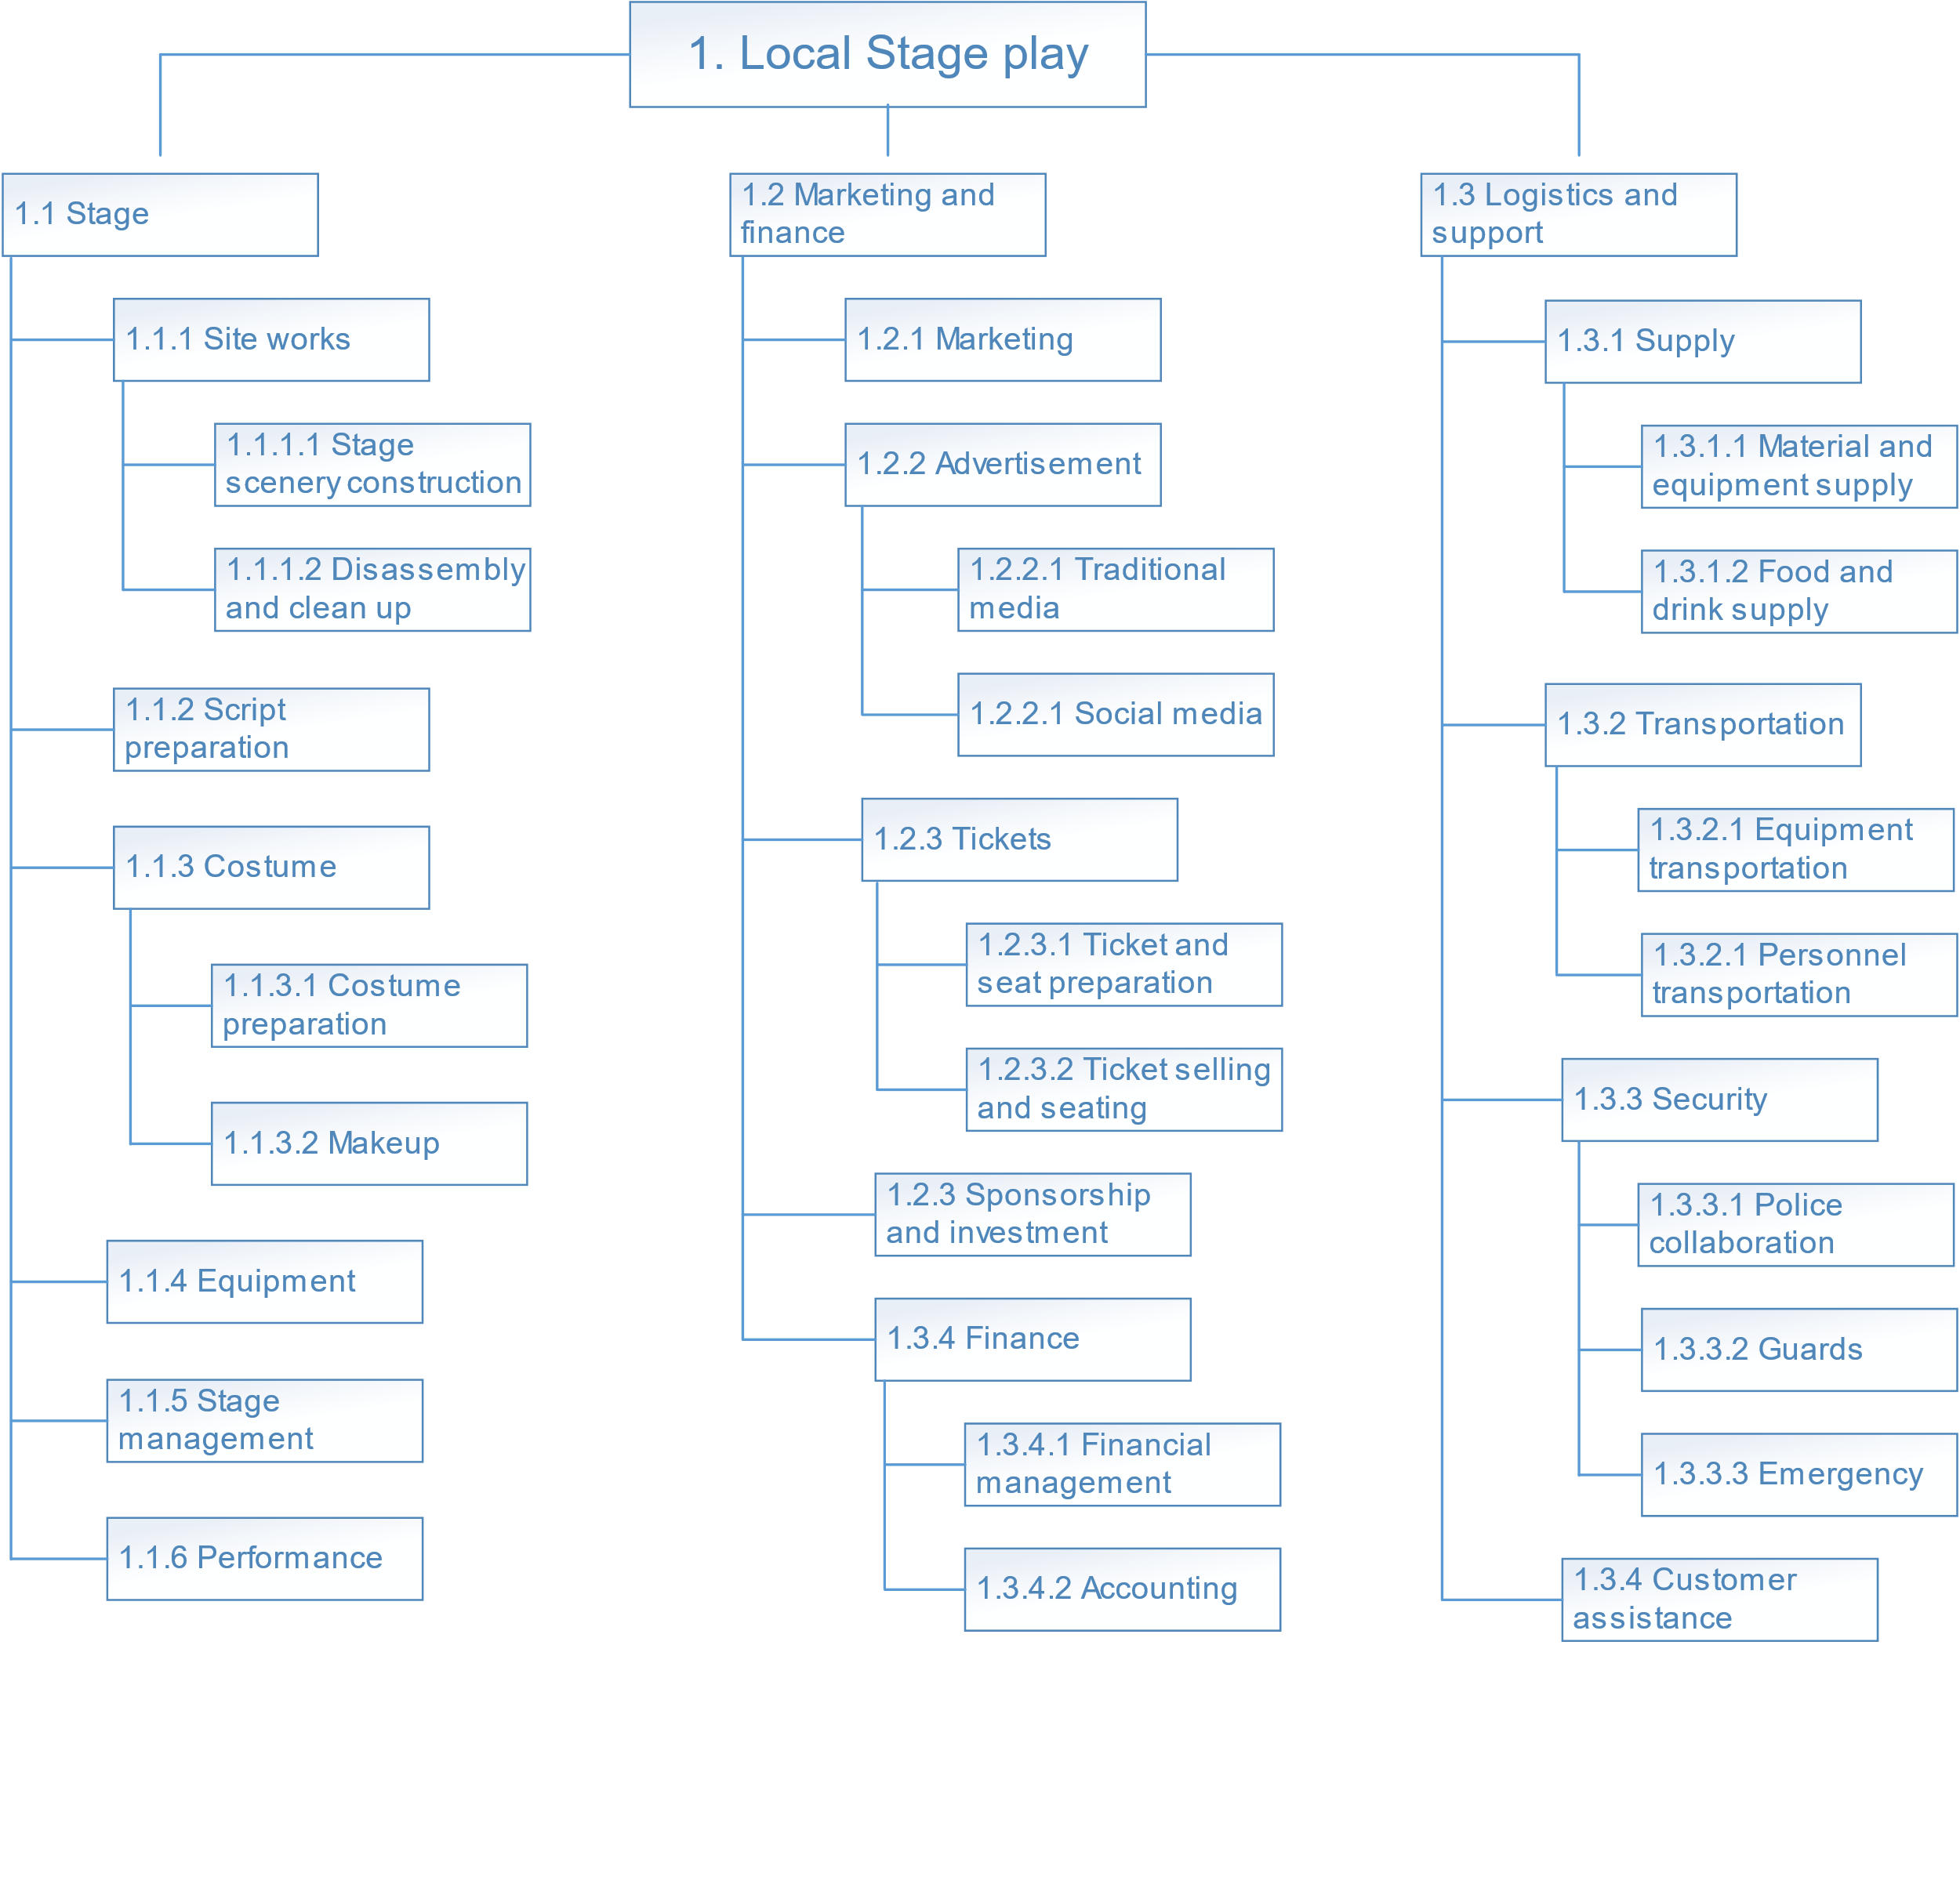**Figure 1**: Work breakdown structure

The work breakdown structure is shown coded in a hierarchy.

We had some small controversy over the cleaning work. Our team pointed out the cleaning involves a large proportion of routine work, but it is essential for the stage play, especially between shows when we would have to clean the stage and switch part of the scenery or background. However, we finally decided that it is not significant enough to be an individual work package, and we decided that it would be merged into site works to form the work package 1.1.1.2 Disassembly and clean up.

**OBS**

Initially some of our team members set up an OBS containing a large number of separate departments. However, during the attempt of intersecting the OBS to the WBS, we realized that too many organizational hierarchies would cause a mess, and since we are dealing with a small budget stage play, many “departments” separated in such a way would contain only 1 or 2 persons, or even share personnel with other departments.

Therefore, we decided to keep the OBS list simple, by dividing it into:

* Administration
* Support/logistics
* Marketing
* Stage performance

In addition, we had more candidates to include in the list:

• **HR**, separated from Administration

• **Design**, separated from Support/logistics

• **Technical**, separated from Support/logistics

• **Finance**, separated from Support/logistics

• **Accounting**, separated from Support/logistics

• **Health, safety and environment**, separated from Support/logistics

Through further discussion, we agreed that since this is a small company, HR would be concurrently held by senior managers or team leaders, and would not make a separate department. The technicians and designers, on the other hand, are highly specialized work which requires dedicated professionals. Also, costume and make up are also part of the broader technical and design range. Therefore, technical and design can be a separate department. We had no further dispute that accounting should be part of finance, and finance should be a separate department, since the nature of their work is very different from the general support and logistics. The majority of us agreed that the nature of health, safety and environment is not highly distinguishable with the support and logistics, and they will not be a separate department when we do not have a large company.

The agreed OBS by our team is:

* Administration/HR
* Support/logistics
* Technical and design
* Marketing
* Finance and accounting
* Stage performance

The structure of WBS intersected with OBS is shown as Figure 2.

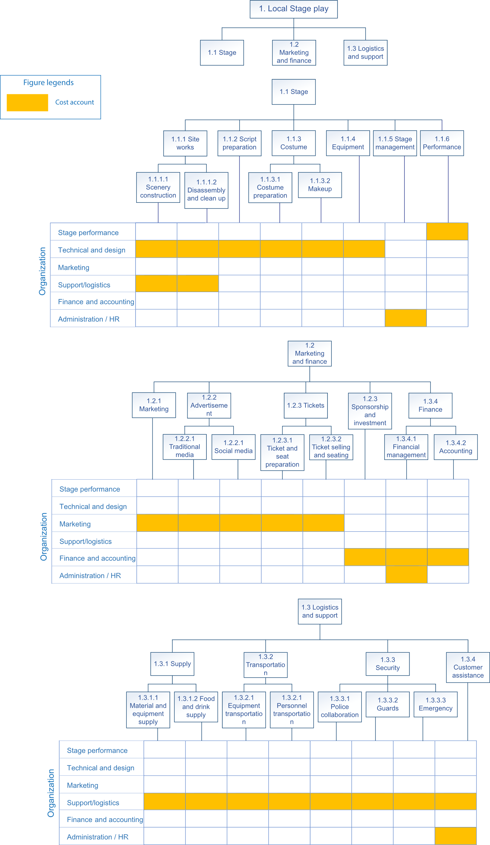

**Figure 2**: Organizational breakdown structure

The work breakdown structure was intersected with the organization breakdown structure and the hierarchy is shown with responsible organizational departments.

**Sample work package**

With discussion, we decided that we will use1.3.2.1 Equipment transportation as the sample work package, because this a relatively more familiar area for us engineering students, in comparison to finance, marketing, stage performance, etc. Equipment transportation is separate from personnel transportation, since a work package is the smallest deliverable for a project, and equipment transportation is distinctive from personnel in terms of types of vehicle, transportation capability, and loading/unloading time.

The work package was presented as Table 1.

|  |  |
| --- | --- |
| Activity | Transportation of materials, equipment, clothing to the site before the play and bringing them back after the play. |
| Responsible people | The support/logistics team |
| Accountable to | PM |
| Resource requirement | 1 medium rigid truck for 2 trips |
| Material | fuel |
| Time | 1 day before the performance, 1 day after the performance |
| Labor | 2 x general labor for loading and unloading.  2 trips x 4 hours including road time and loading, unloading.  Driver cost is included in vehicle rental. |
| Output deliverable | 1.3.2.1 Equipment transportation |
| Budget | Delivery van rental $200 x 2 trips, fuel $40. Total $440 |

**Table 1**: A sample work package

The work package 1.3.2.1 Equipment transportation is presented in details as a sample work package.

CONCLUSION

In this project, by teamwork, we defined the scope of a local stage play, and determined its deliverables, WBS, OBS, and a work package. Before each item of the project, each of our team presented our own designs and then discussed about them. The discussion effectively exchanged our ideas, and by expressing our opinions, we successfully persuaded each other and reach agreements in time.

During our project, our PM’s successfully managed the progress of the project, and our team members kept pace with the timetable of the project plan. Everyone participates in all the topics equally, and by this way, the WBS, OBS and work package were generated within the scheduled time frames.

LESSONS LEARNT

By working on this project, we have gained actual experience on planning of projects. Through this mimic project, we have learnt first-hand experience on how scheduling a project is like, and by working on the scope, the deliverables, the WBS and OBS, we have applied our knowledge learnt from the lectures, combined with practice knowledge. This piece of experience will be useful in the future when we step into engineering projects in the real-world scenario.

In addition, when we worked on the project, we further enhanced our teamwork skills. This project, with 7 topics in 2 weeks, has a rather intensive time frame. What adds to the difficulty was that the deliverables of this meta-project depend on each other, e.g. without reaching an agreement on deliverables, the WBS could not be established, and without an agreed WBS, we would not be able to work on an OBS accordingly. Our PMs successfully managed the discussion following critical milestones determined in the plan, and finalized each topic by summarizing it. Our team members happily accepted the team agreement after discussion, and all agree to proceed based on a uniformed ground into the next stage. By doing this, we avoided the case when controversies stack up as we generate increasing discrepancies through more topics. This allowed us to reach a final agreement efficiently.